1. Write a program in assembly language to take a single-digit integer from the user

and print it on the screen.

Code

ORG 100h

MOV DX, OFFSET msg_input

MOV AH, 09h

INT 21h

MOV AH, 01h

INT 21h

MOV BL, AL

CMP BL, '0'

JL NotDigit

CMP BL, '9'

JG NotDigit

MOV DX, OFFSET msg_output

MOV AH, 09h

INT 21h

MOV DL, BL

MOV AH, 02h

INT 21h

JMP EndProgram

NotDigit:

MOV DX, OFFSET msg_error

MOV AH, 09h

INT 21h

EndProgram:

MOV AH, 4Ch

INT 21h

msg_input DB 'Enter a digit: $'

msg_output DB 0Dh, 0Ah, 'The entered digit is: $'

msg_error DB 0Dh, 0Ah, 'Error: Not a digit! $'

END

OutPut:

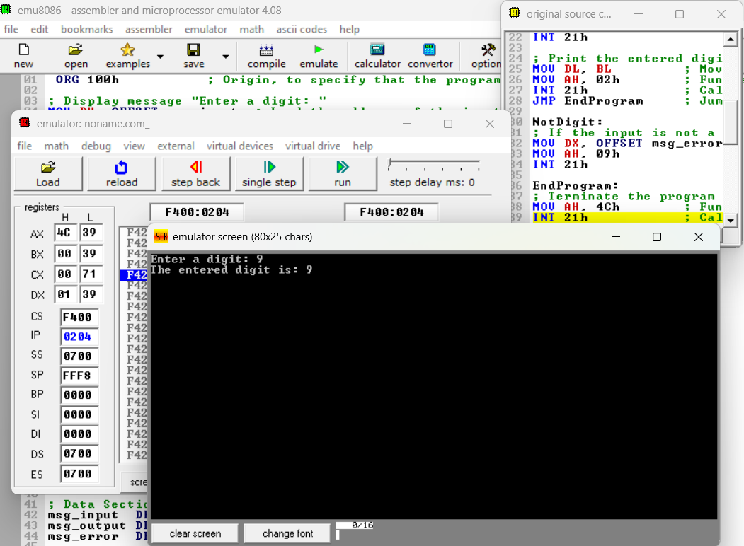

Practice set:

2. Write a program in assembly language to take two single-digit integers from the user and print the result of subtraction on the screen.

Code

ORG 100h

MOV DX, OFFSET msg_input1

MOV AH, 09h

INT 21h

MOV AH, 01h

INT 21h

SUB AL, '0'

MOV BL, AL

MOV DX, OFFSET msg_input2

MOV AH, 09h

INT 21h

MOV AH, 01h

INT 21h

SUB AL, '0'

MOV BH, AL

SUB BL, BH

MOV DX, OFFSET msg_output

MOV AH, 09h

INT 21h

CMP BL, 0

JGE PositiveResult

MOV DL, '-'

MOV AH, 02h

INT 21h

NEG BL

PositiveResult:

ADD BL, '0'

MOV DL, BL

MOV AH, 02h

INT 21h

EndProgram:

MOV AH, 4Ch

INT 21h

msg_input1 DB 'Enter the first digit: $'

msg_input2 DB 0Dh, 0Ah, 'Enter the second digit: $'

msg_output DB 0Dh, 0Ah, 'The result of subtraction is: $'

END

OutPut:

